**Multimedia & Graphics**

**Class Six**

**Lab 17**

|  |
| --- |
| Lab Objectives: Poster Design |

Poster Name: **Perfect Afternoon**

# Scenario:

The sun will be set within an hour which is seen above from a tree house. Kids are playing beside a lake. In the sky ravens are going back to their home.

Illustrate something like that so that you can feel this is a perfect afternoon.

Choose every picture from clipart

Steps:

1. Take a tree house
2. Choose river from clipart
3. Search kids and select one of them who is playing something
4. Add an image where a girl runs with her pet
5. Add some raven in the sky
6. Add sun above the tree
7. Use light yellow color from vector fill to your background
8. Finally export your image

Procedures are showing below:



2)

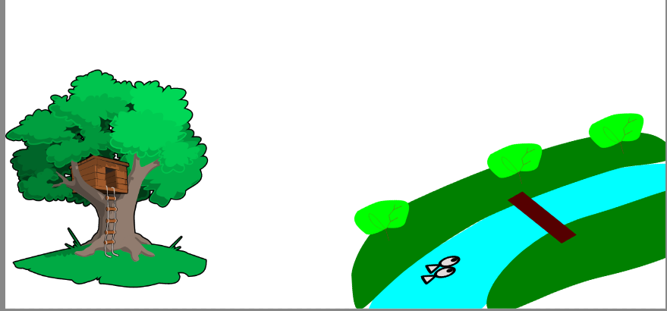

3)

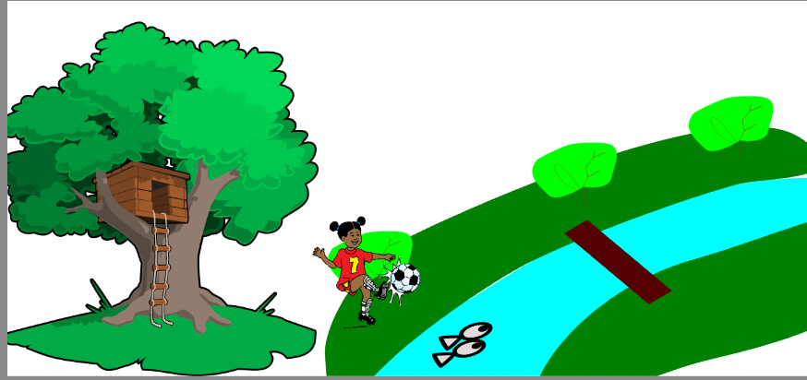

4)

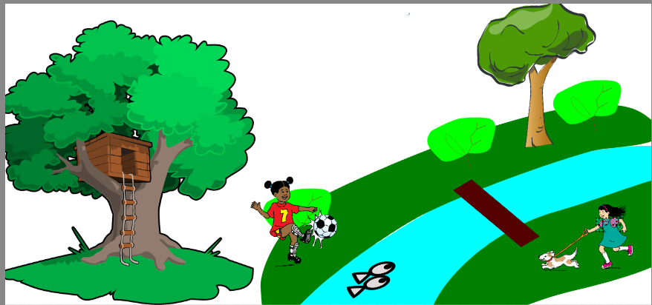

5)

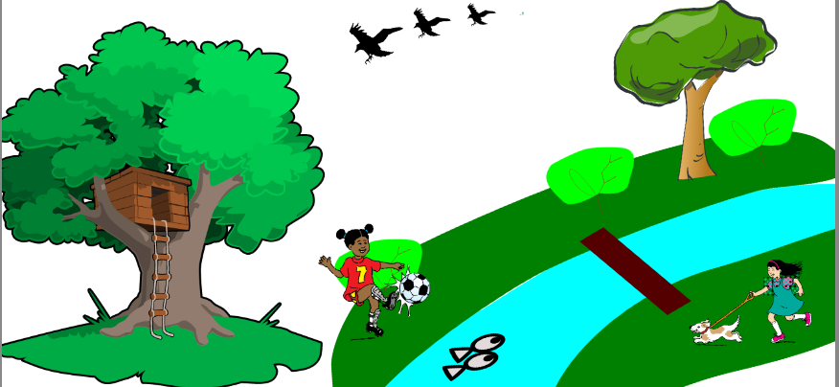

6)

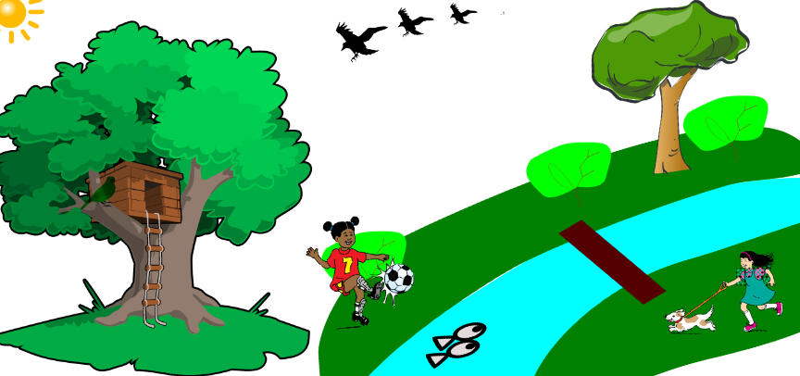

7)

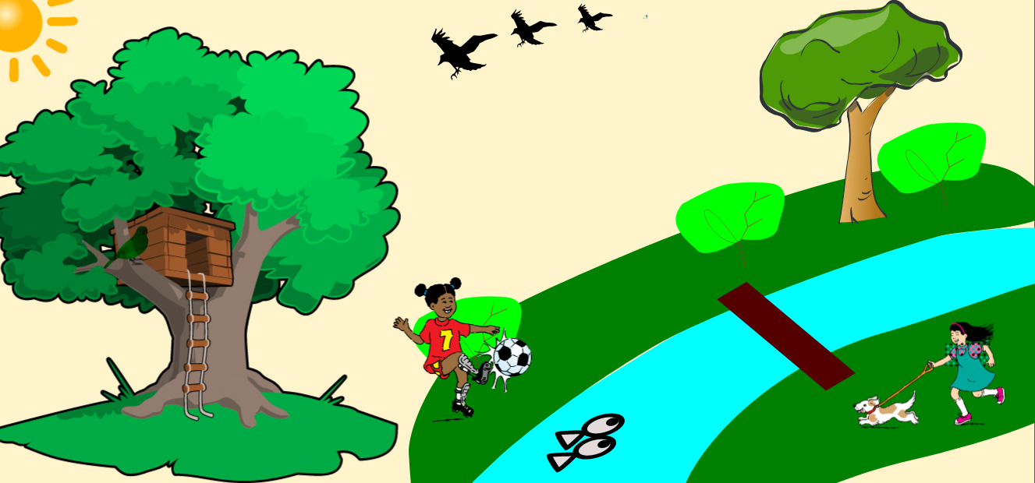

Finally our “***Perfect Afternoon”***

